Analyzing COVID-19 World Vaccination Progress

Introduction
Welcome to the Power BI project focused on analyzing the COVID-19 vaccination progress worldwide. This exercise aims to utilize Power BI functionalities to explore, visualize, and derive insights from the provided vaccination data.

Case Study Number & Title
Analyzing the COVID-19 World Vaccination Progress data for observing and drawing inferences on vaccination statuses around the world.

Background Information
The dataset contains country-level vaccination data from 2020 to 2022 (March). It includes information such as total vaccinations, people vaccinated, people fully vaccinated, daily vaccinations, etc.

Problem Statement/ Business Objectives
The objective of this project is to analyze the vaccination data to discern trends and extract relevant insights using Power BI.

Data Description
The data is provided as a CSV file with the following attributes:
- Country
- Country ISO Code
- Date
- Total number of vaccinations
- Total number of people vaccinated
- Total number of people fully vaccinated
- Daily vaccinations (raw)

- Daily vaccinations
- Total vaccinations per hundred
- Total number of people vaccinated per hundred
- Total number of people fully vaccinated per hundred
- Number of vaccinations per day
- Daily vaccinations per million
- Vaccines used in the country
- Source name
- Source website

You can access the dataset from (https://www.kaggle.com/datasets/gpreda/covid-world-vaccination-progress?select=country_vaccinations_by_manufacturer.csv).

Questions and Tasks
1. Create three Card visuals for India
- Display Total Vaccinations
- Display People Vaccinated
- Display People Fully Vaccinated
- Add a slicer for Date to choose only Year and Month information.

2. Create a Clustered Column Chart
- Display the top 10 countries with the highest number of fully vaccinated people in the year 2021.

3. Create a Grayscale Map
- Display bubbles indicating total vaccinations for all countries.

4. Create a Clustered Bar Chart
- Display the Top 10 countries with the highest number of daily vaccinations.

- Add a slicer for Date to choose only Year and Month.
- Observe trends in 2020 and 2021.

5. Analyze Trend in India
- Observe the trend for people who are fully vaccinated in India.

Solution
A solution workbook is provided with the dataset.

Key Takeaways/Results
- Analyzing data using Power BI facilitates deriving meaningful insights, aiding decision-making processes.

Dashboard
The dashboard for this project is included in the solution workbook provided with the dataset. It contains visualizations and insights derived from the COVID-19 vaccination data.

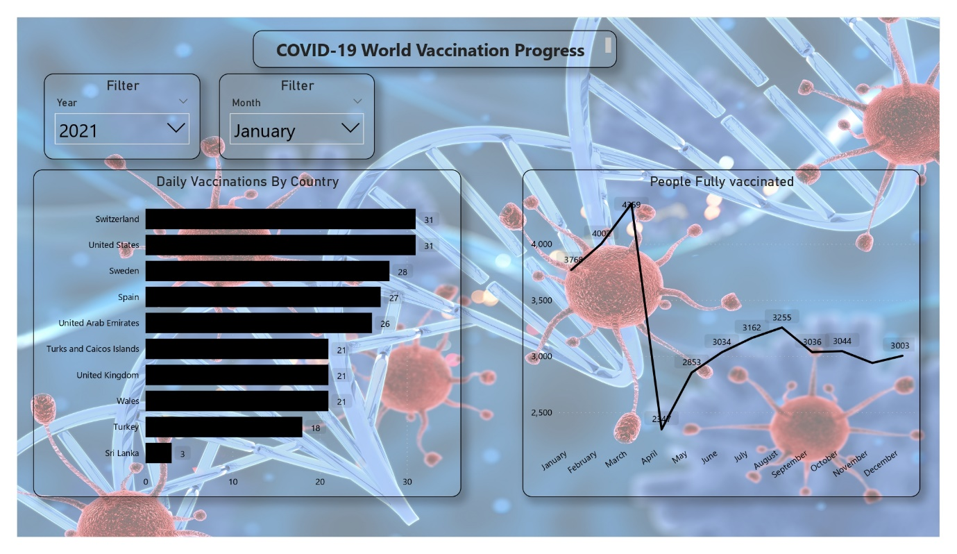

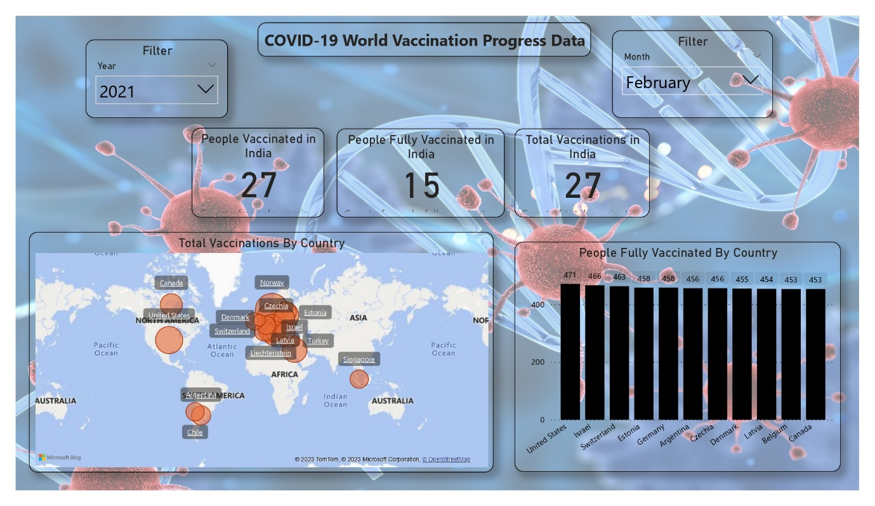

Feel free to explore the dashboard and interact with the visualizations to gain insights into the vaccination progress worldwide. If you have any questions or need further assistance, please don't hesitate to reach out.

